**Database Management Systems Project**

**Military base**

Zhanuzak Raiymbek, Nurdaulet Didar, Kanat Nuradil

Introduction

The database project encompasses various entities representing a military organization, capturing essential information about soldiers, medics, missions, equipment, operations, exam results, divisions, security details, and vehicles. This comprehensive database aims to efficiently manage and organize data related to the personnel, resources, and activities within the military structure. Each entity plays a distinct role in capturing specific attributes, allowing for a holistic view of the organization's operations.

Entities and their attributes():

**Soldiers**(IIN varchar(255), Name varchar(255), Surname varchar(255), Father_Name varchar(255), Birthdate varchar(255), Gender varchar(255), Family varchar(255), Address varchar(255), Soldier_rank varchar(255), Status varchar(255), Commander_IIN varchar(255), Hire_Date varchar(255), Contract_type varchar(255), Rebukes int, Salary int)

* IIN Primary key

**Medics**(IIN varchar(255), Name varchar(255), Surname varchar(255), Father_Name varchar(255), Birthdate varchar(255), Gender varchar(255), Family varchar(255), Address varchar(255), Soldier_rank varchar(255), Status varchar(255), Commander_IIN varchar(255), Hire_Date varchar(255), Contract_type varchar(255), Rebukes int, Salary int)

* IIN Primary key

**Missions**(Mission_ID int, Description varchar(255), Type varchar(255), Commander_IIN varchar(255), Status varchar(255))

* Mission_ID primary key
* Commander_IIN foreign key

**SnM**(Soldier_IIN varchar(255), Mission_ID int)

* Soldier_IIN foreign key
* Mission_ID foreign key

**Equipments**(Equipment_ID int, Equipment_Name varchar(255), Production_Year int, Made_In varchar(255), Status varchar(255))

* Equipment_ID primary key

**EnM**(Equipment_ID int, Mission_ID int)

* Equipment_ID foreign key
* Mission_ID foreign key

**Operations**(Soldier_IIN varchar(255), Medic_IIN varchar(255), Assistant_IIN varchar(255), Description varchar(255), Injury_Type varchar(255), Records varchar(255))

* Soldier_IIN foreign key
* Medic_IIN foreign key
* Assistant_IIN foreign key

**Exam_Results**(IIN varchar(255), Name varchar(255), Surname varchar(255), Weight double(10, 1), height double(10, 1), Hun_run double(10, 1), 6km_Run double(10, 1), Shooting int, Pullups int, Psychotest varchar(255))

* INN primary key

**Divisions**(Divivsion_ID int, Division_Type varchar(255), Commander_IIN varchar(255), Soldier_Count int)

* Divivsion_ID primary key

**Security**(Soldier_IIN varchar(255), Location varchar(255), Duration varchar(255))

**Vehicle**(Vehicle_ID int, Vehicle_Name varchar(255), Vehicle_Type varchar(255), Production_Year varchar(255), Made_in varchar(255), Status varchar(255))

* Vehicle_ID primary key

**VnM**(Vehicle_ID int, Mission_ID int)

* Vehicle_ID foreign key
* Mission_ID foreign key

**MnM**(Medic_IIN varchar(255), Mission_ID int)

* Medic_IIN foreign key
* Mission_ID foreign key

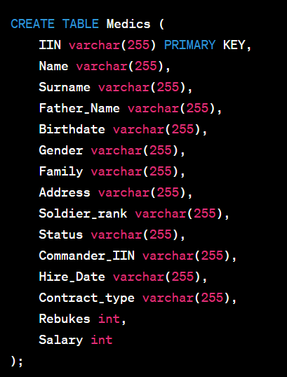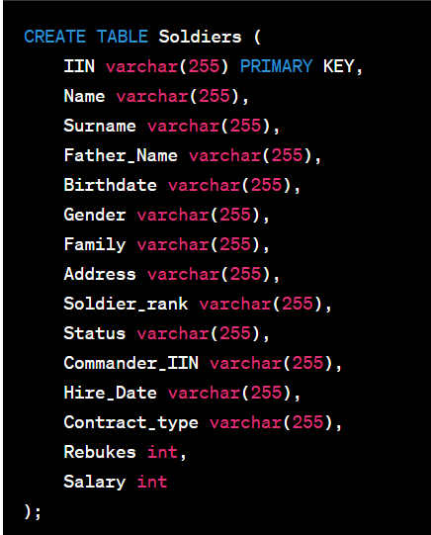Creation of Entities:

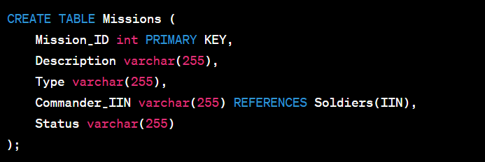

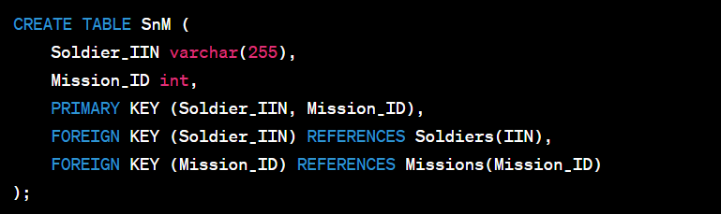

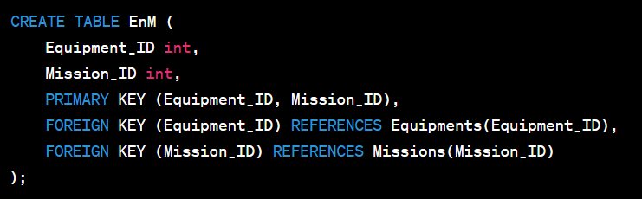

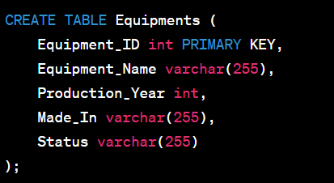

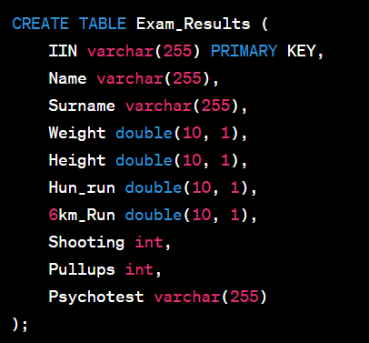

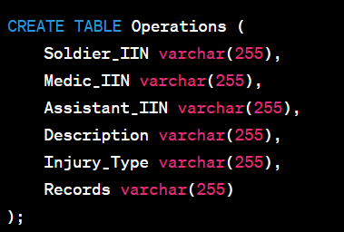

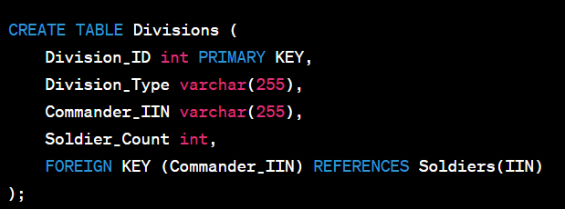

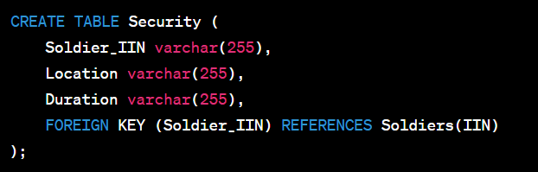

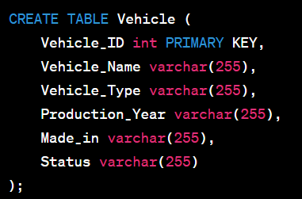

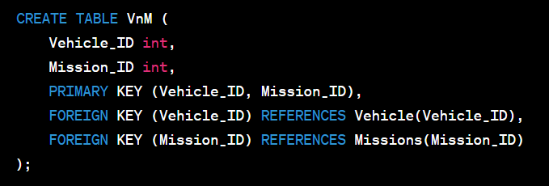

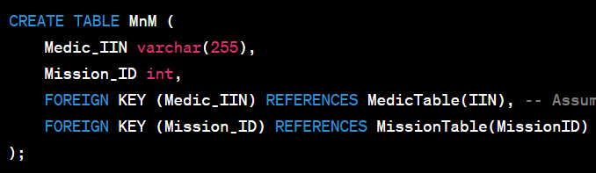

Our dates

1. 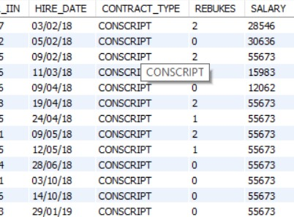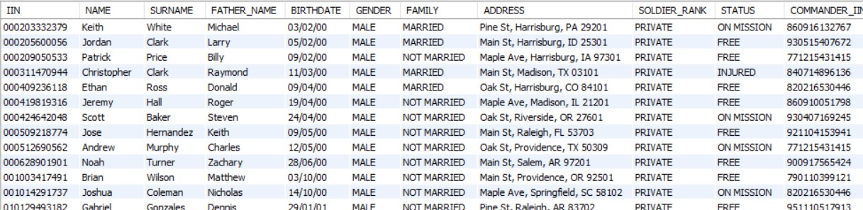Soldier table
2. 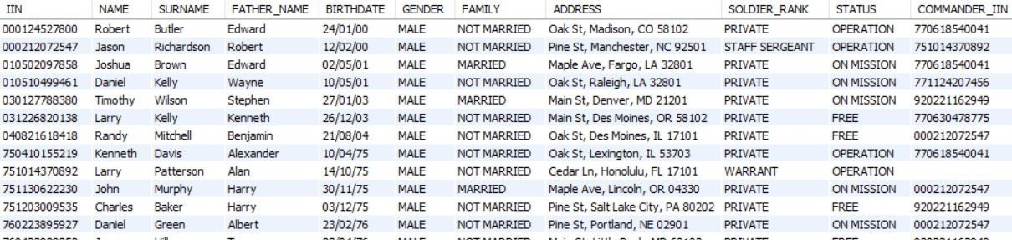Medics table

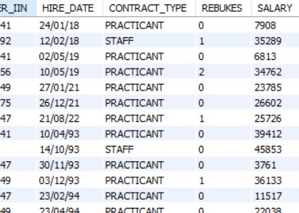

1. Vehicle table

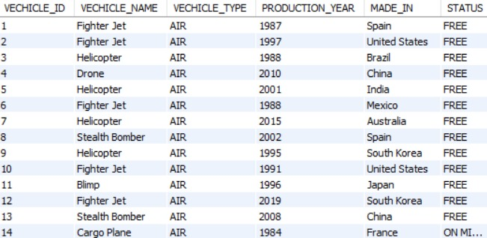

1. Equipment table

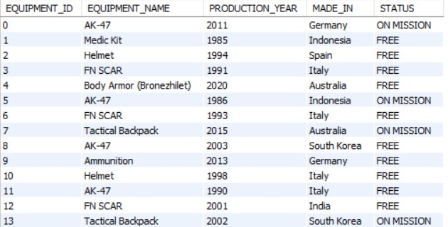

1. Operation table
2. 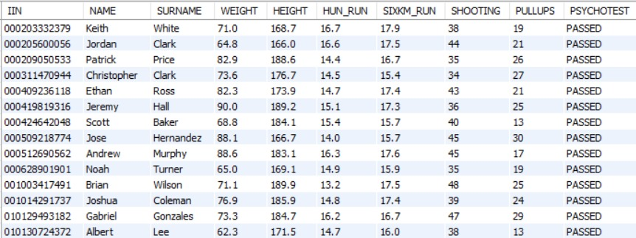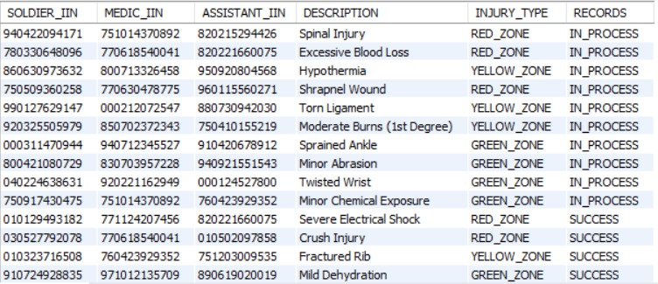Exam_Results table
3. Mission table

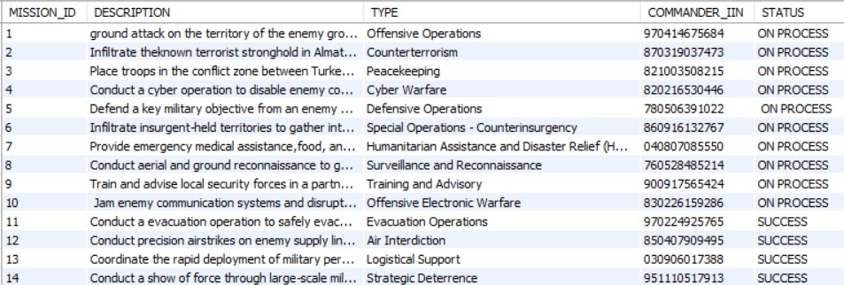

1. Devision table

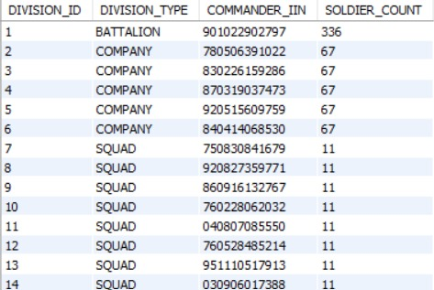

1. Security table

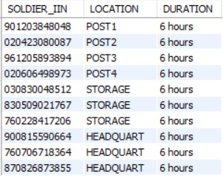

1. 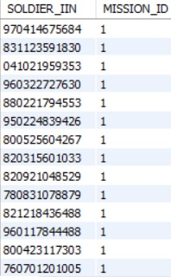SnM table(Soldiers and Missions)
2. EnM table (Equipments and Missions)

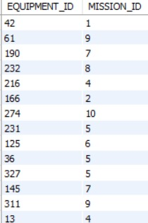

1. 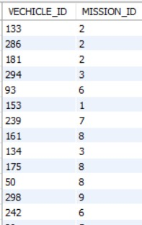 VnM table (Vehicle and Missions)
2. MnM(Medics and Missions)

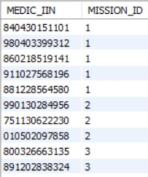

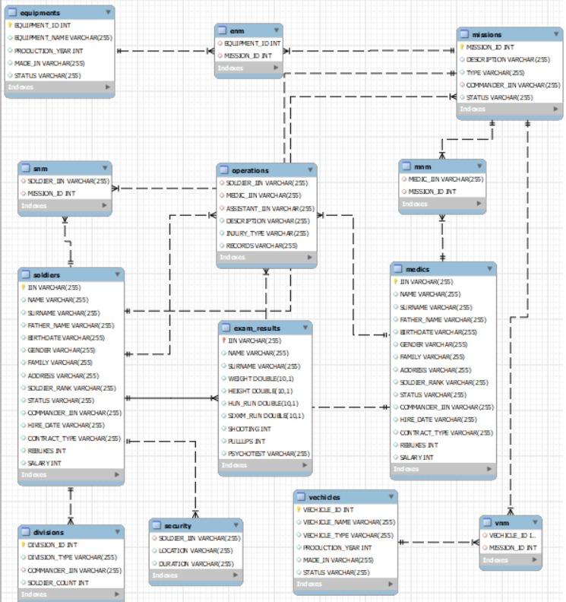Entity – Relationship Diagram

We have many relations among the tables. Soldiers have one to many relations with Security, because one location or post can have many soldiers but one soldier can have one post, also Soldiers have one to many relations with Operations. We have column STATUS, depends one it operations can be already ended and because of it one soldier can have many operations, but he can have only one operation in one time. They have many to many relation between missions with same things like operation, but for their relation we have bonus table between them. Medics have double one to many relation with operation, because we have two columns to reference them. With missions same situation like Soldiers and it is also for Equipments and Vehicles

Normalization

We normalized main tables to BCNF form. We don't have any columns with many values, each column identifies by IIN or ID and noting can be primary key instead of them, and nothing can identify primary key.

Example

|  |  |  |  |  |
| --- | --- | --- | --- | --- |
| Soldiers | | | | |
| Soldier_IIN | Name | Surname | Status | Rank |

Instead of this

|  |  |  |  |  |  |
| --- | --- | --- | --- | --- | --- |
| Missions | | | | | |
| Mission_ID | Description | Mission_Type | Commander_IIN | Soldiers_IIN | Status |

Instead of this we have this

|  |  |
| --- | --- |
| SnM(Soldiers and Missions) | |
| Soldier_IIN | Mission_ID |
| 970414675684, 831123591830, 041021959353 | 1 |
| 000203332379, 900701440355, 960616153599 | 2 |
| 040530856251, 970201677294, 970623325691 | 3 |

|  |  |
| --- | --- |
| SnM(Soldiers and Missions) | |
| Soldier_IIN | Mission_ID |
| 970414675684 | 1 |
| 831123591830 | 1 |
| 041021959353 | 1 |
| 000203332379 | 2 |
| 900701440355 | 2 |
| 960616153599 | 2 |
| 040530856251 | 3 |
| 970201677294 | 3 |
| 970623325691 | 3 |

‘Vehicle and Missions”, “Equipment and Missions” tables same

Queries

SQL Basics

1. 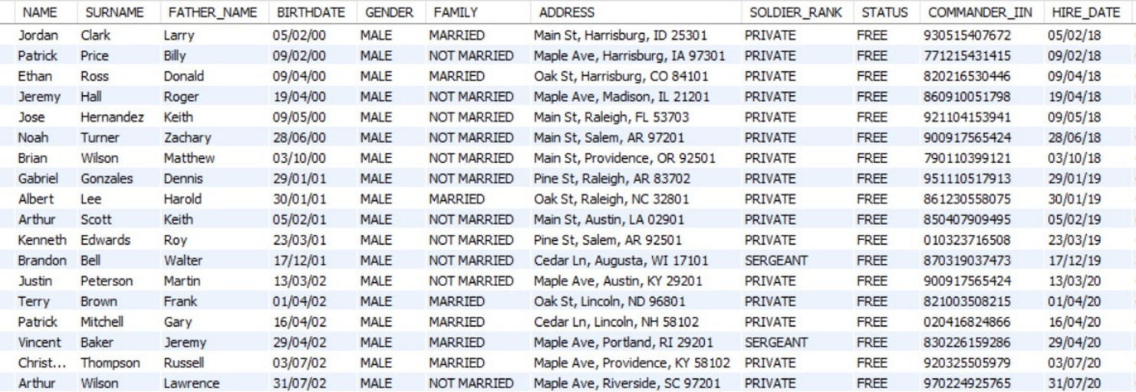Find soldiers hired between '1985-01-01' and '2021-12-31' whose free
2. 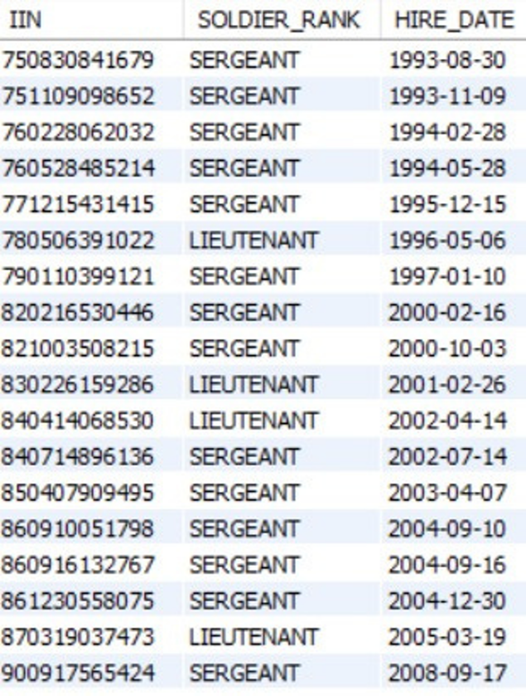Retrieve soldiers who not private and sort them by hire date in ascending order
3. Retrieve all vehicle that on the mission and sort them by their type

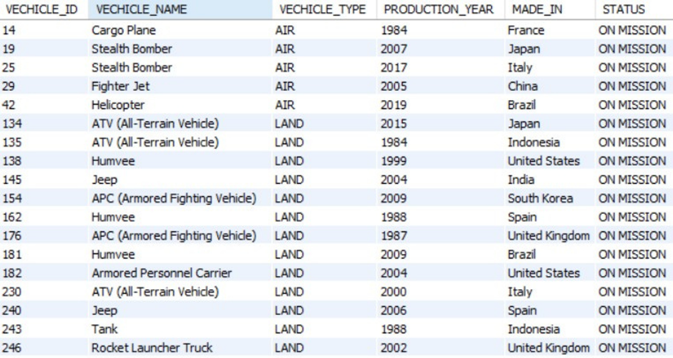

1. 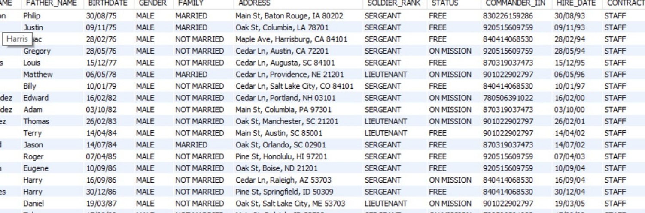Retrieve all soldiers who have a rank more than private and work more than 5 years
2. Retrieve name and surname of soldiers whose age more than 20

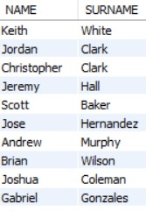

Aggregations

1. Top 3 soldier ranks with the highest average salary

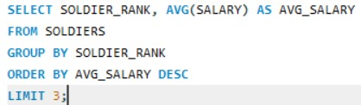

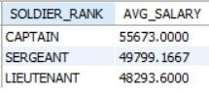

1. Mission types and count of equipments used in each type

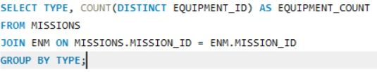

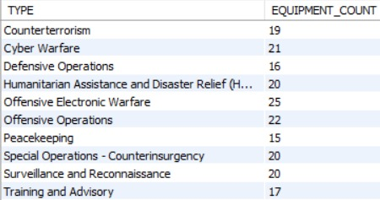

1. 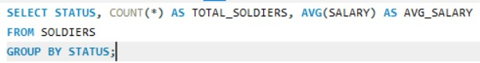Total soldier count and average salary by status

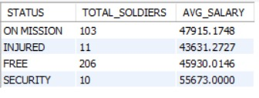

1. 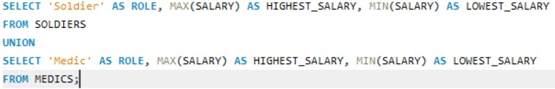Highest and lowest salary among soldiers and medics

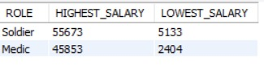

1. Most common injury type in operations with average salary of affected soldiers

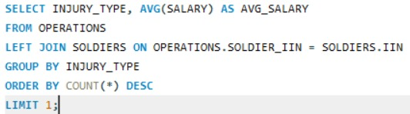

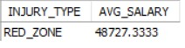

Index

1. Create an index on Soldier_rank column in Soldiers table



1. Create an index on Weight column in Exam_Results table



Triggers

1. 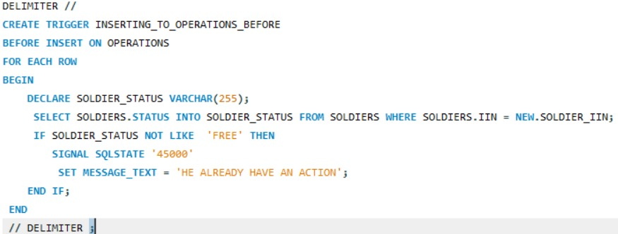**Before Insert.**
2. 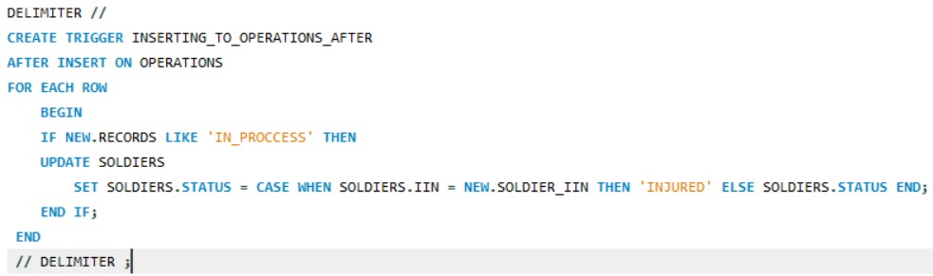**After Insert**
3. 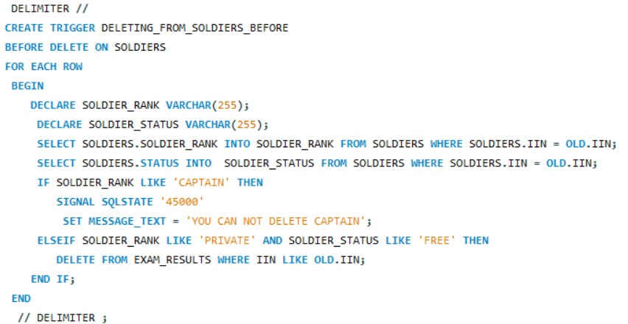**Before Delete**
4. **After delete**

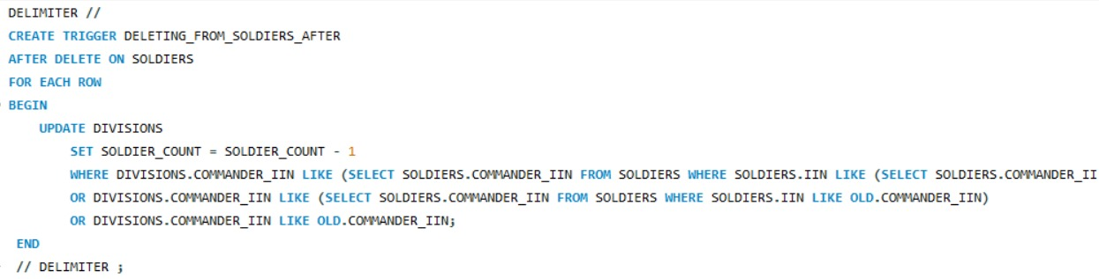

1. 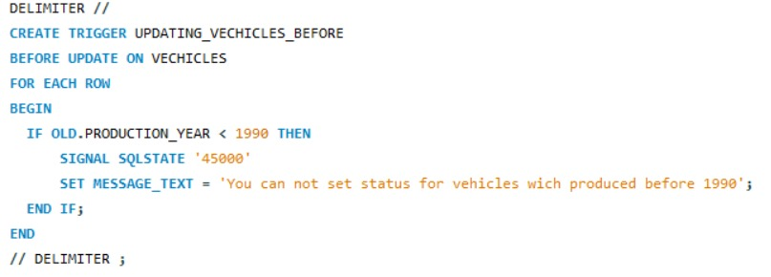**Before Update**
2. **After Update**

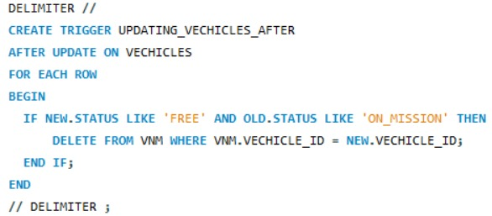

Subquery

1. ****Find the commanders of soldiers with IIN 780501417570, 870319037473. Include name, surname, rank and status

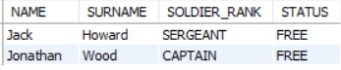

1. Find equipments which production year less than production year of equipment with Equipment_ID = 628

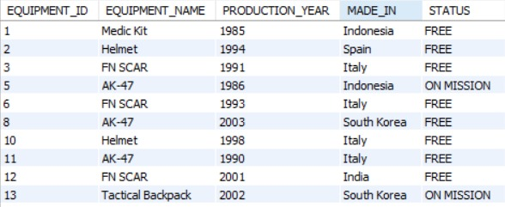

1. Find medics whose have a higher salary than any medic who on the operation
2. Soldiers with Salary above Average

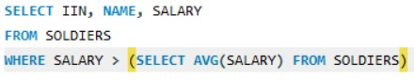

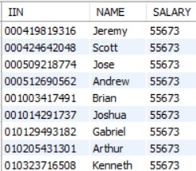

1. Total missions of each commander

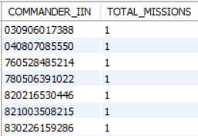

1. 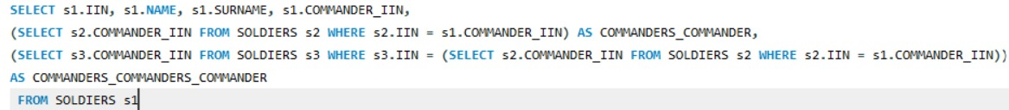Retrieve hierarchical relations of each soldier

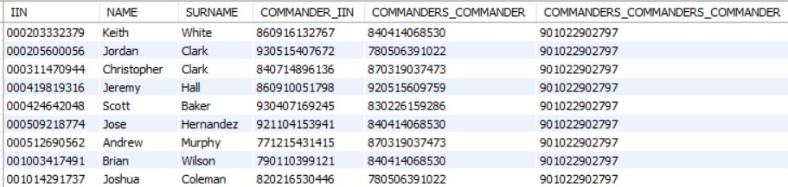

Joins

1. 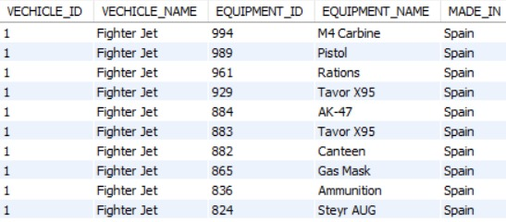 Retrieve vehicles which have a same production country with equpments
2. 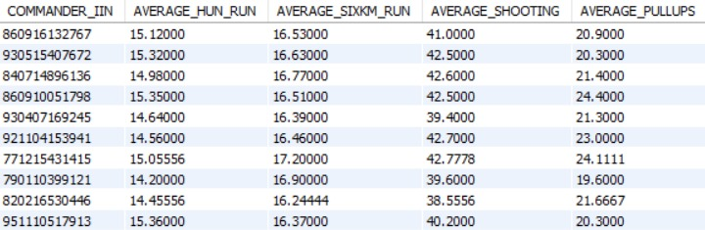Retrieve average of each exam result on each squad
3. Combine Soldiers and Equipments by Missions

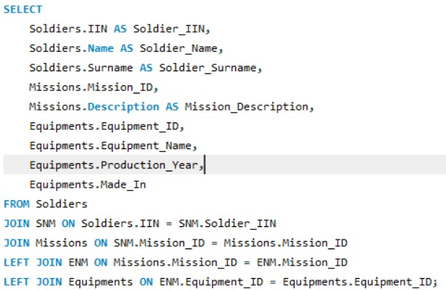

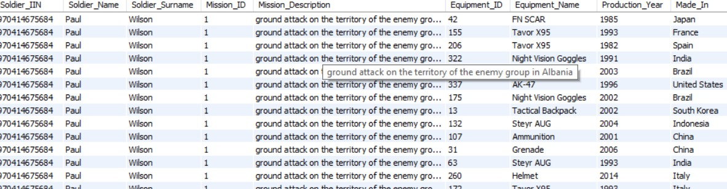

Window Functions

1. 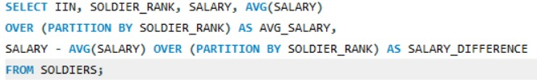Calculate Average Salary Difference from Soldier's Rank Average

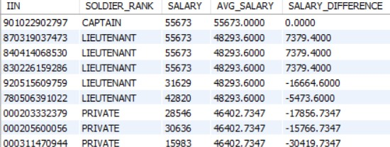

1. 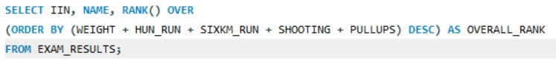Rank Soldiers Based on Exam Results Percentile

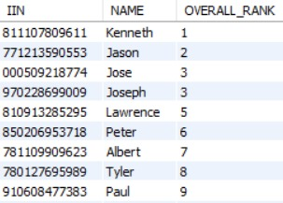

1. 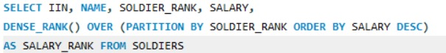Rank soldiers by Soldier rank and Salary

